1) Mark floor with the desired post configuration.
2) Mark each hole diameter at 77mm.
Tip. Mark the edges of the drill core as the centre will not be visible when
aligning the drill head.
3) Drill using a suitable diamond drill core. Drill hole 10mm beyond the length of
the socket
4) Break out core and chisel out the base of the hole if domed.
5) Vacuum out the excess debris and dust from the drilled core.
6) Pour adhesive anchor grout to approximately one third+ depth of the core.
Use a Certite pourable & thixtropic anchor grout or equivalent.
7) Insert the socket onto the post.
8) insert the post into the drill core.
9) Check level of the post, adjusting with suitable wedges under the base plate.
10) Leave grout to cure for recommended length of time.
​
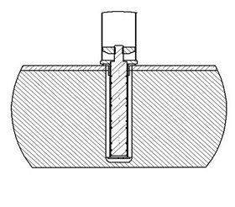​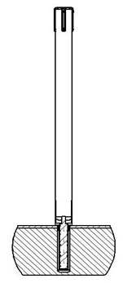

1) With the blanking plug removed, position the base of the post to the recess of the floor socket and push firmly down.
2) When fully fitted, the base of the post will sit flush with the top of the floor socket. To remove the post, pull directly upwards until removed.

